INTRODUCTION:
This is a guide in using the Retail and Big Box Agency Procurement Request (APR) application. This application will automatically create a big box or retail APR based on the new packaging of items in PS. Using this guide, you can get around the basic functions and features of APR application that ensure you with of a fast and efficient way of preparing an APR.
SYSTEM REQUIREMENTS:
The APR application is a macro programming in excel that will work in any computer that has MS Excel 2003 and above.
LIMITATIONS:
The application is not compatible in any machine that has a MAC Operating System.
INSTALLING THE PROGRAM
- Download the excel file named (APR FORM NO. 01.xlsm) and open the file.

Note: To download the file, go to http://www.procurementservice.gov.ph , click the APR form app link in the Downloads menu.

- Enable the macros in excel.

Option A: If the Microsoft Office Security Alert appear

a.1. Click the Options button when you see the Security Warning Alert. (See Figure A.1)

(Figure A.1)

a.2. Select the option: Enable this content. This option will allow macros to run within the current spreadsheet.
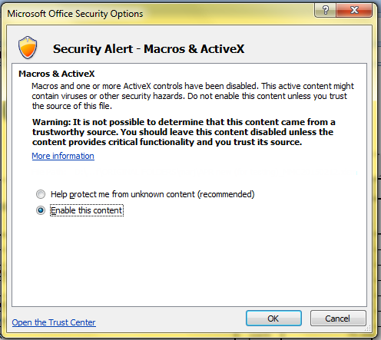
(Figure A.2)

a.3. Click Open the Trust Center link. In the new window that appears, choose Macro Settings from the sidebar and select Enable all macros (not recommended; potentially dangerous code can run) and check the Trust access to the VBA project object model. Click OK to exit the Trust Center. (See Figure A.3)

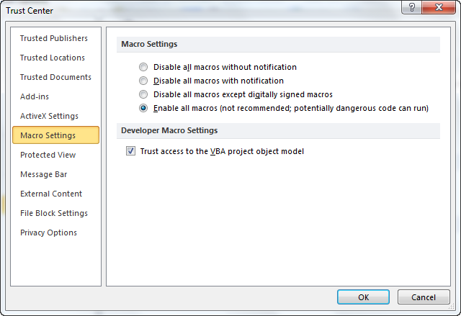
(Figure A.4)

a.4. Click the Ok button in the Microsoft Office Security Alert Option to save the changes.

Option B: If no alert is displayed, manually enable the macros.
b.1. Click the Microsoft Office Button . The Microsoft Office button is located in the upper left corner of the screen.

b.2. Click the Excel Options button, located at the bottom of this menu. (See Figure B.1)

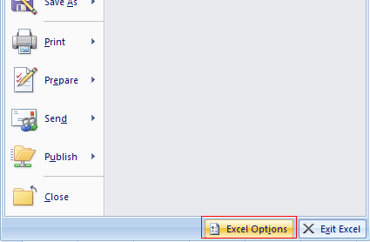
(Figure B.1)

b.3. Click the Trust Center tab on the left side of the screen then click the Trust Center Settings button, located on the bottom-right of the screen. (See Figure B.2)

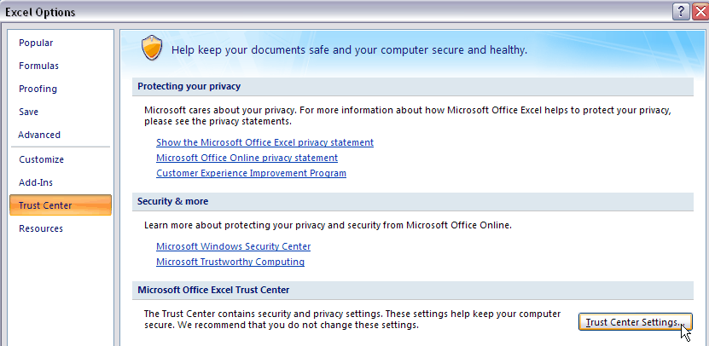
(Figure B.2)

b.4. In the new window that appears, choose Macro Settings from the sidebar and select Enable all macros (not recommended; potentially dangerous code can run) and check the Trust access to the VBA project object model. Click OK to exit the Trust Center. (See Figure B.3)
(Figure B.4)

GETTING STARTED
THE CATALOGUE
The catalogue displays all the items that can be ordered in the Procurement Service.
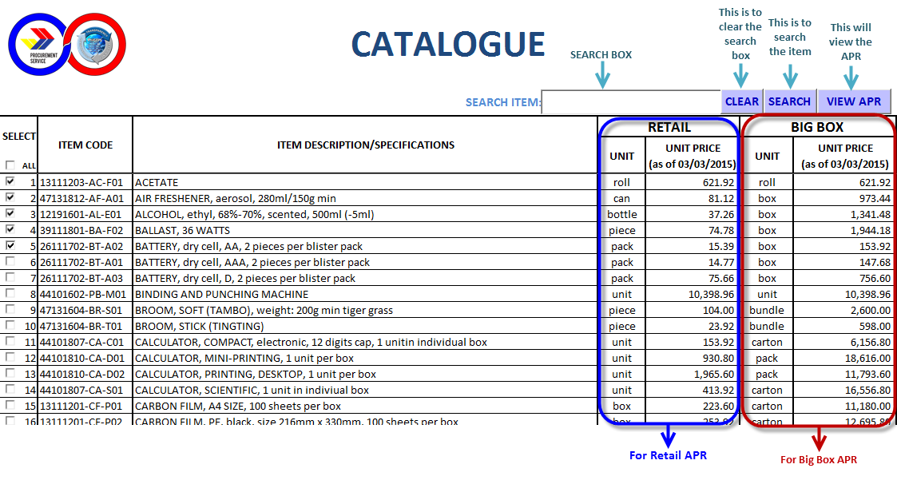
CREATING AN APR
- Select an item/s from the Catalogue by Clicking the checkbox () beside the sequence number to include the item in the APR form.
Note: The user will not be able to proceed in the APR form if no item was selected.

Using the search box: type a keyword in the search box and Click ‘SEARCH’ button.

- Click the ‘VIEW APR’ the Reminder message will pop-up. Click ‘OK’ button the Draft APR form will be displayed.
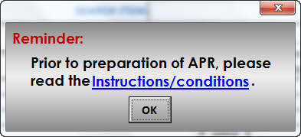

THE DRAFT APR
The Draft APR displays all the items you have selected in the Catalogue.

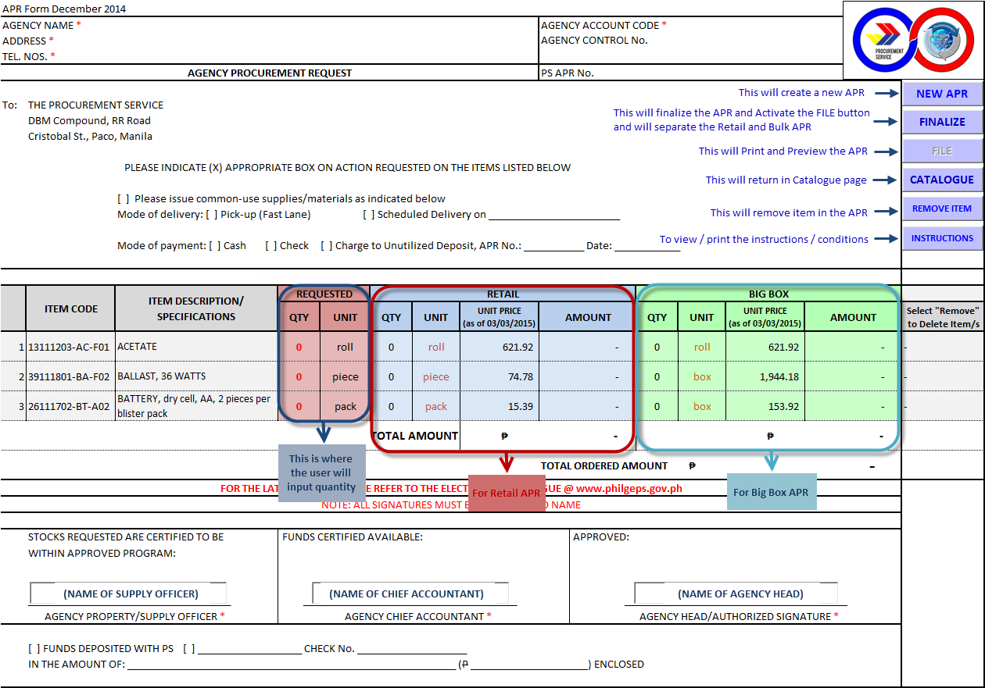
UPDATING THE APR
- The Agency Supply Officer will enter the following:
- Agency Name
- Agency Account Code (given by PS-Accounting)
- Address
- Telephone number
- Name of the Supply Officer
- Name of the Agency Chief Accountant
- Name of the Agency Head

- Indicate the quantity per item in QTY column under REQUESTED group (Quantity must be greater than a number). The application will automatically determine whether the quantity indicated is for Retail or Big Box orders. The Total Amount of Retail and Big Box and the Total Ordered Amount of the APR will also be computed.
Note: All field with asterisk (*) are mandatory fields. Missing required data will not allow user to finalize the APR.

- To remove item/s in the list, select ‘Remove’ in the dropdown list under ‘Select “Remove” to Delete Item/s’ column on corresponding line item then click ‘REMOVE ITEM’ button.

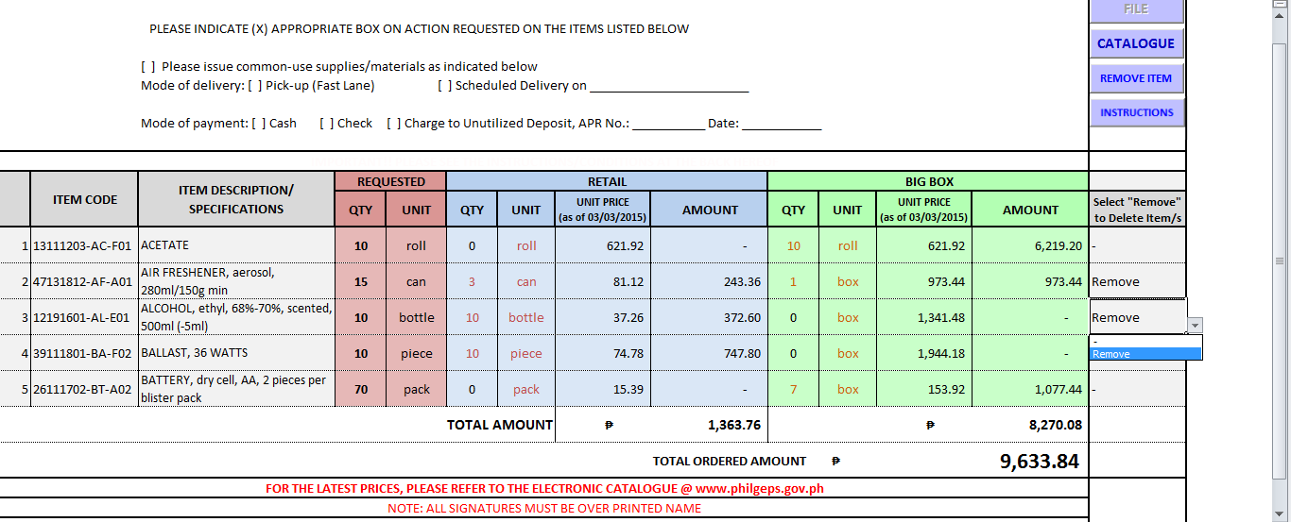

FINALIZING THE APR
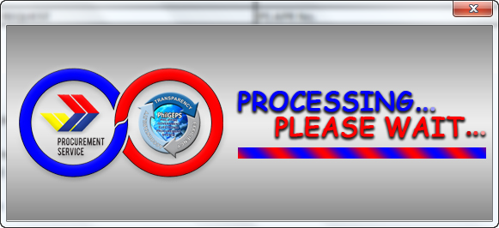
To Generate the final APR, click the ‘FINALIZE’ button. The system displays the message “Are you sure you want to finalize this APR? Note: Clicking YES, will finalize this APR and can no longer be modified.” The “File” button will enable.
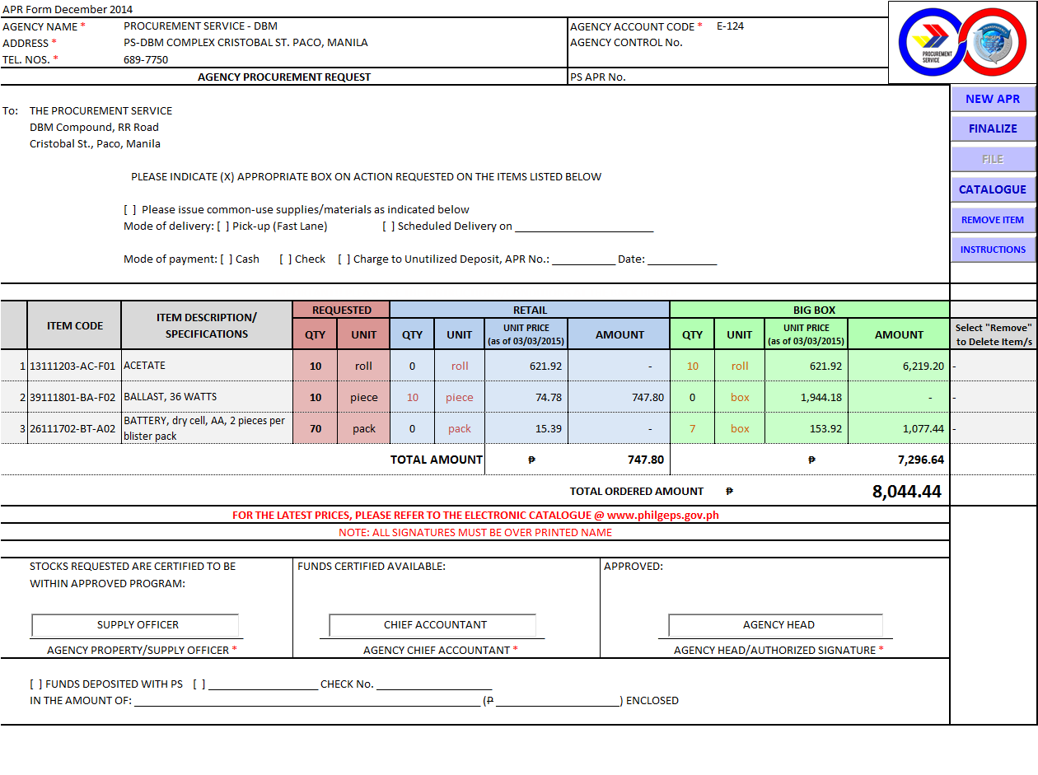

PRINTING/PREVIEWING THE APR
- To Print or Preview the APR, user clicks the ‘FILE’ button, Supply Officer selects the Retail, Big Box or both APR/s then click Preview or Print.

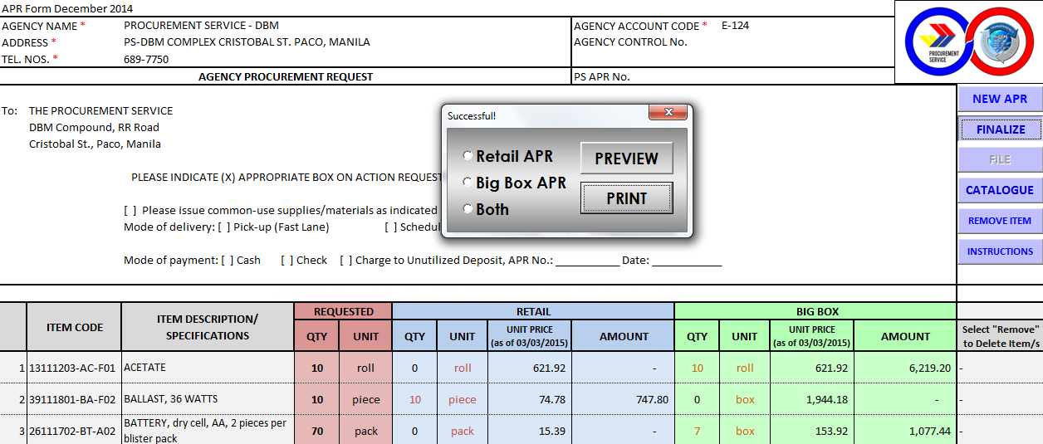

CLOSING THE PROGRAM
- Close the excel file and click ‘Don’t Save’ button.

INSTRUCTIONS/CONDITIONS
- Click ‘Instructions’ button in the APR module to review the Instructions and Conditions in procuring common-use supplies. To print, click the ‘Print’ button at the end of the page.
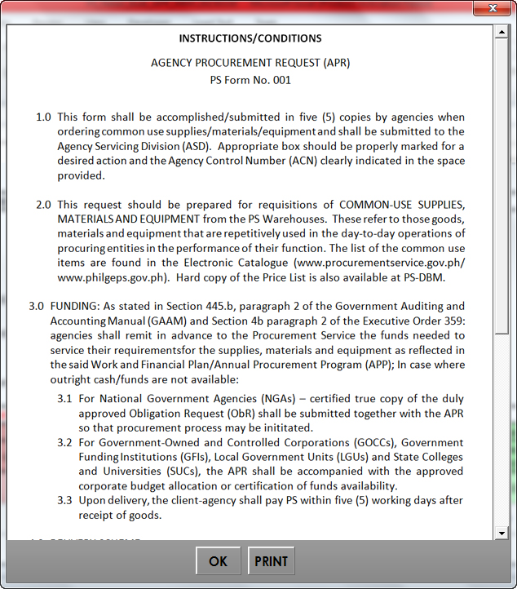

Sample APR-Retail Preview
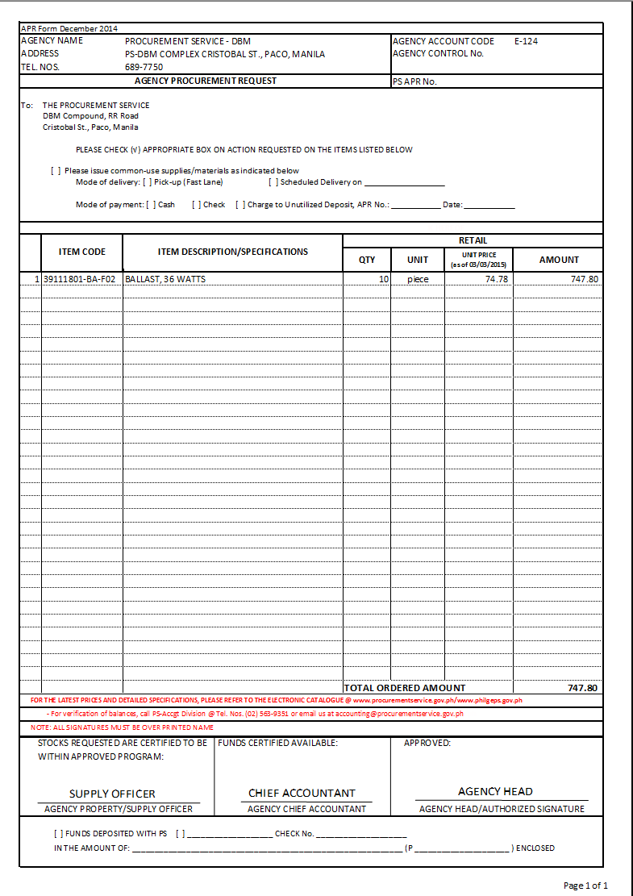
Sample APR-Big Box Preview
